Name: _____________________
Full Test (Calc Free + Calc Assumed)

Total Time: 35 minutes

Total Marks: 29 marks

Student Result ________/ 29


MATHEMATICS METHODS Unit 3
TEST 1 -2023: Further differentiation, integration and applications.
Part A

Calculator Free Section
Time: 22 minutes
Total Marks: ______ / 19 marks

Resources allowed: SCSA Formula Sheet

Instructions to candidates
Show all your working clearly. Your working should be in sufficient detail to allow your answers to be checked readily and for marks to be awarded for reasoning. Incorrect answers given without supporting reasoning cannot be allocated any marks. For any question or part question worth more than two marks, valid working or justification is required to receive full marks. If you repeat any question, ensure that you cancel the answer you do not wish to have marked.

Question 1 | [2, 2, 2 = 6 marks]

Determine $\frac{dy}{dx}$ for each of the following. Do not simplify your answer.

a) $y=3x^{2}-\frac{4}{x}+\sqrt{x}$

b) $y=\frac{5x^{2}}{3x+2}$

c) $y={\left(x^{2}-4\right)}^{3}$

Question 2 | [3 marks]

Find the value of $f''(2)$ for $f\left(x\right)=\frac{x+1}{x-1}$

Question 3 | [4, 2 = 6 marks]

Consider the function, $f\left(x\right)=\frac{8}{x^{2}}+2x$.

a) Determine the coordinates of all the stationary points for $f(x)$ and use the second derivative to determine their nature.

b) Find the coordinates of the global minimum and maximum points of $f\left(x\right)$ over the
interval $1≤x≤4$.

Question 4 | [2, 2 = 4 marks]

Determine each of the following indefinite integrals. Express you answers with positive indices where appropriate.
$$\int{{\left(3x-7\right)}^{4}}dx$$
a)

$$\int{\frac{3}{{\left(2x+5\right)}^{2}}}dx$$
b)

Name: _____________________


MATHEMATICS METHODS Unit 3
TEST 1 -2023: Further differentiation, integration and applications.
Part A

Calculator Assumed Section
Time: 13 minutes
Total Marks: ______ / 10 marks

Resources allowed:
SCSA Formula Sheet
Up to three Calculators and
One A4 sheet, both sides of notes

Instructions to candidates
Show all your working clearly. Your working should be in sufficient detail to allow your answers to be checked readily and for marks to be awarded for reasoning. Incorrect answers given without supporting reasoning cannot be allocated any marks. For any question or part question worth more than two marks, valid working or justification is required to receive full marks. If you repeat any question, ensure that you cancel the answer you do not wish to have marked.

Question 5 | [1, 2, 4, 2, 1 = 10 marks]

A rectangle OABC is such that O is always at the origin, A lies on the $x$-axis, C lies on the $y$-axis and B lies in the first quadrant on the curve $y=16-{\left(x+1\right)}^{2}$.
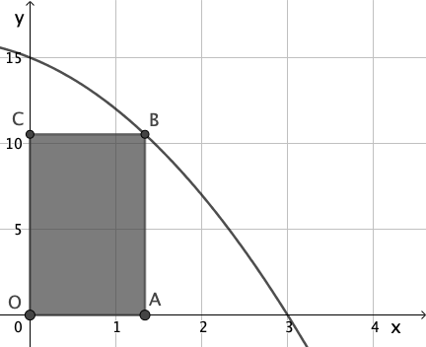
1 unit on each axis is 1 cm.

a) Find the area of the rectangle when $x=2$.

b) Show that the area of rectangle OABC is given by $A=15x-2x^{2}-x^{3}$, where $x$ is the $x$-coordinate of corners A and B

c) Use calculus (first and second derivatives) to determine the maximum area of the rectangle.

d) i) Use the increments formula $δA≈\frac{dA}{dx}δx$ to find the approximate change in area of the rectangle when $x$ increases from 2 to 2.1 cm.

ii) Interpret this answer in the context of this question.

End of Test

